# Generative Adversarial Networks (GANs)

def. An ML model in which 2 neural networks compete with each other to become more accurate in their predictions.

* Typically run unsupervised and use a cooperative, zero-sum1 game framework to learn
* The 2 neural networks competing against each other are called a *generator* and a *discriminator*
* GANs basically generate their own training data

**Generator**: A convolutional neural network whose goal is to artificially manufacture outputs that can easily be mistaken as real data.

**Discriminator**: A deconvolutional neural network whose goal is to correctly identify which outputs from the generator are artificial.

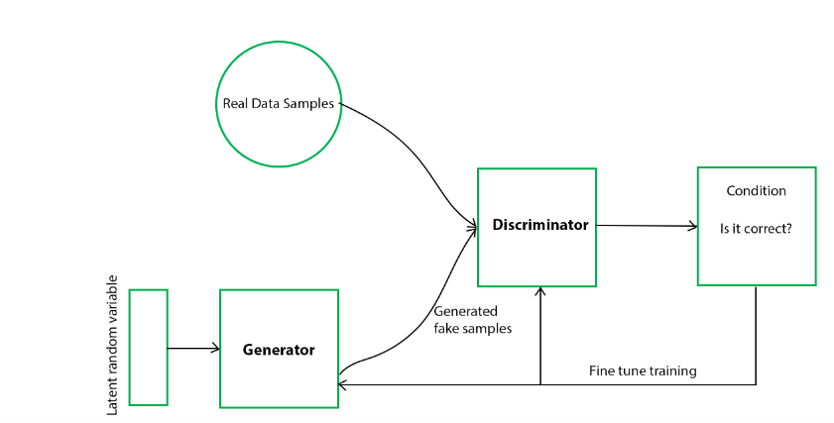

(Fig.1 General flow chart of the works of a GAN)

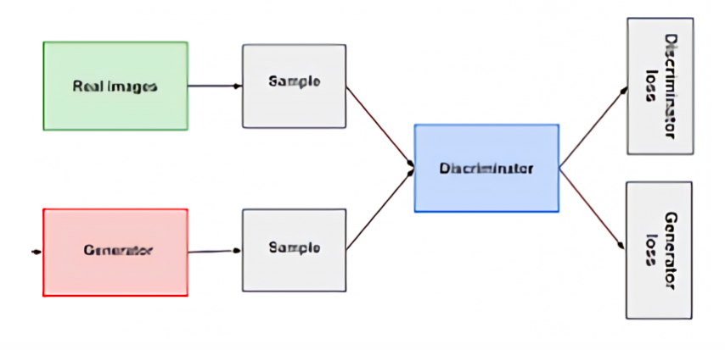

(Fig.2 GAN architecture from the perspective of neural networks (i.e., generator and discriminator))

## How do GANs work?

**Step 1**: Identify the desired end output and gather an initial training dataset based on those parameters.

**Step 2**: Randomize data and input into the generator until it acquires basic accuracy in producing outputs.

**Step 3**: Following **Step 2,** generated images are fed into discriminator, along with actual data points from the original concept.

Discriminator filters through this info and returns a probability between 0 and 1 to represent each image’s authenticity (1 for real, 0 for fake).

**Step 4**: These values are manually checked for success and repeated until the desired outcome is reached.

## What are some viable use cases for GANs?

* Filling in images from an outline
* Generating realistic image from text
* Producing photorealistic depicions of product prototypes
* Converting black and white imagery into color
* **Creating new image data for small sample datasets**

## What are some common types of GANs?

1. **Vanilla GAN:** The simplest type of GAN consisting of a generator and discriminator, where the classification and generation of images is done by the generator and discriminator internally w/ the of multi-layer perceptrons.
2. **Conditional GAN**: For this type, the generator and discriminator are both provided w/ additional info (i.e., a class label). This additional info helps the discriminator in finding the conditional probability instead of the joint probability.
3. **Deep Convolutional GAN (DCGAN):** DCGANs have generators that use deep convolutional networks, making them capable of generating high resolution images to be differentiated.

ReLu activation is used in Generator layers except for last layer, where Tanh activation is used.

Leaky-ReLu is used across all layers of the Discriminator.

Adam optimizer is used.

1. **Cycle GAN (CGAN)**: Made specifically for image-to-image translations, meaning one image is mapped w/ another.

# Best Models for Cancer Detection

1. Zero-sum is a situation from game theory in which one person's gain is equal to another's loss, so the net change in wealth or benefit is zero. A zero-sum game may have as few as two players or as many as millions of participants.

# Histology Practices

Sources for GANs:

[1] <https://www.analyticsvidhya.com/blog/2021/10/an-end-to-end-introduction-to-generative-adversarial-networksgans/>

(an all-encompassing into to creating GAN)

[2] <https://machinelearningmastery.com/how-to-develop-a-conditional-generative-adversarial-network-from-scratch/>

(how to develop a conditional GANfrom scratch in python)

[3] <https://calvintchi.github.io/pdf/CS280_report.pdf>

(report on data augmentation using GANs for IDC dataset)

[4] <https://towardsdatascience.com/conquer-class-imbalanced-dataset-issues-using-gans-2482b52593aa>

(tips and tricks to make GANs work / more stable)

Takeaways going forward

-> train on each image patch and classify as malignant or benign

-> develop a GAN to fix class imbalance

-> use CNN for classification tasks

-> research further explainable AI methods later down the line